ValidateXMLs deployment

Cd C:\Users\Niels Postma\PycharmProjects\ValidateXMLs

Python setup.py sdist

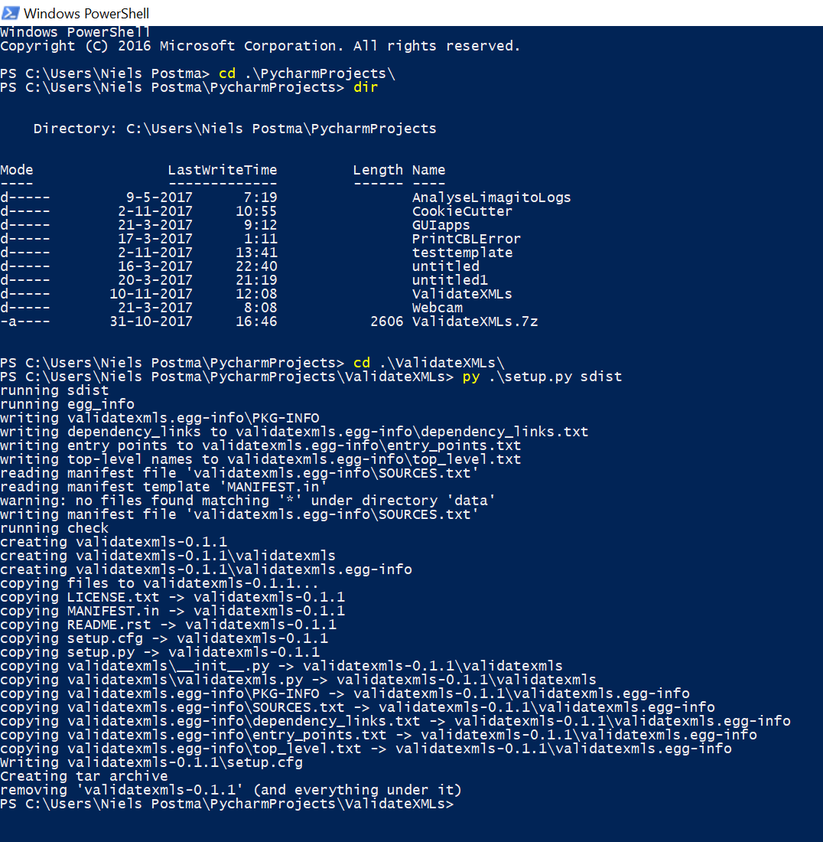

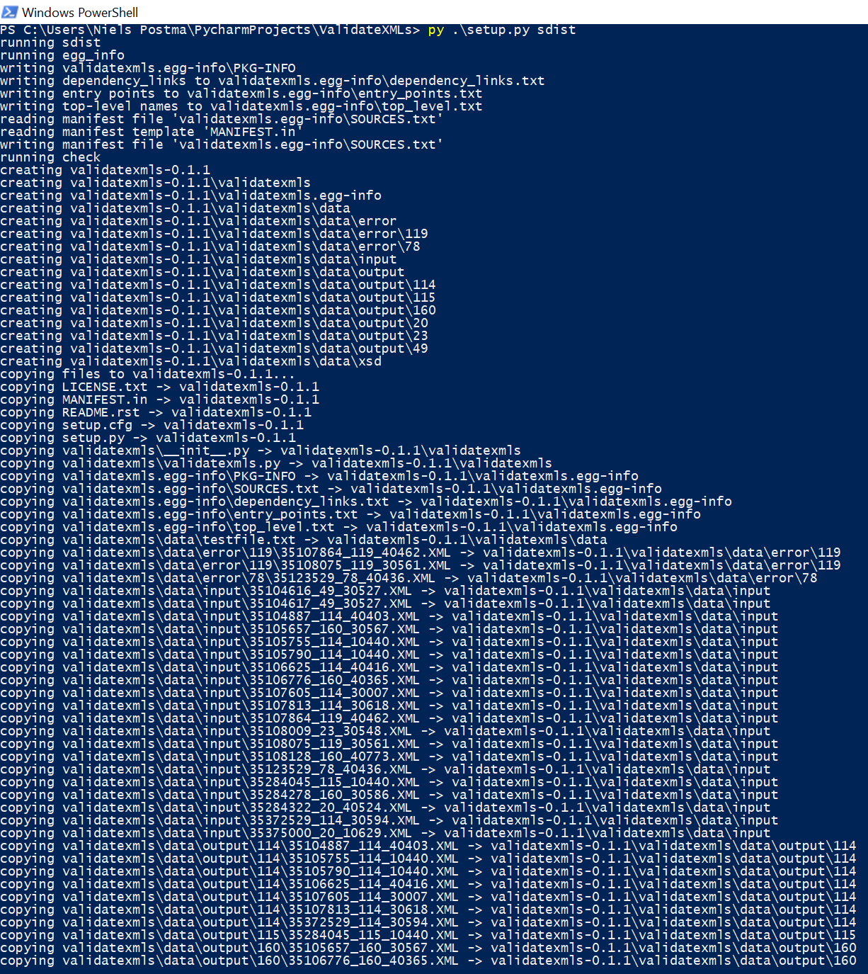

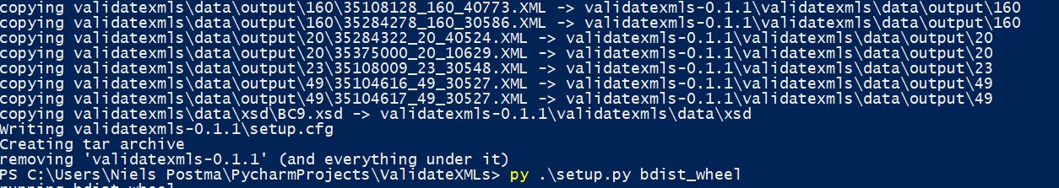

Python setup.py bdist_wheel

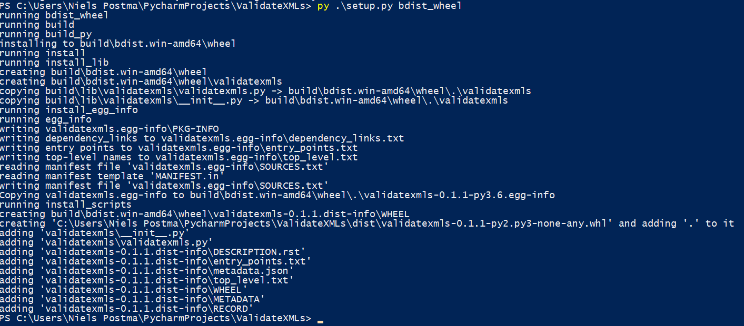

Twine (upload to PyPI)

$ *# One needs to be explicit here, globbing dist/* would fail.*

$ twine register dist/project_name-x.y.z.tar.gz

$ twine register dist/mypkg-0.1-py2.py3-none-any.whl

Twine upload dist/*

Cookiecutter

Installing a template